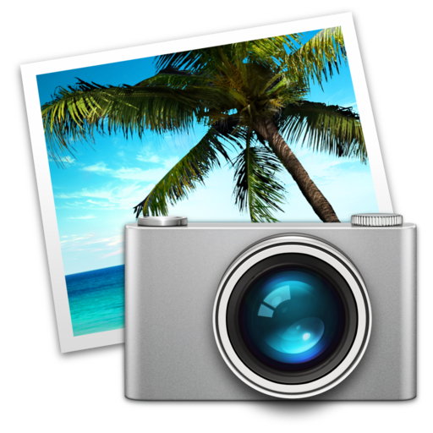
Iphoto

How to download your digital photos

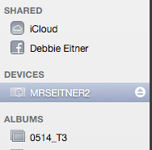
- Open iPhoto
- Put your SD card in the slot on the computer.
- Wait for the SD card to show up in the finder menu for iphoto.
- Add your first and last name to the event window.

5. Hold down the command key ⌘ and select the photos you want to import to the computer.

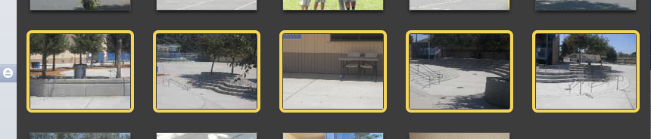
- Click on “Import Selected”
- If you are not sharing the images with anyone else, delete them from the SD card.
- Then should now be in your iPhoto Library in the Event with your name.
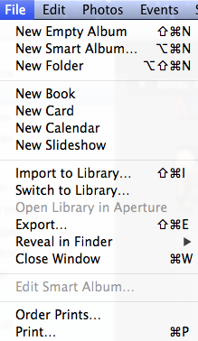
How to export your images

1. In iPhoto, double click on the event for the pictures you want to export.
2. Select the images you want to export to the desktop, by holding down the command key ⌘ while you are selecting the images.
3. One method: Drag and Drop your images to the desktop.
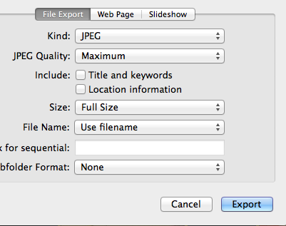
4. Second method: Click on FILE > EXPORT, choose the size and type of image. Then click EXPORT. (This is used when you want to use a lower resolution image or a different size to save memory space for emailing or save memory space.)
5. From the desktop, you can place them on a USB drive, move them to a cloud account or burn them to a disk.

