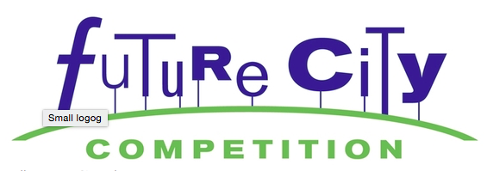
Are you interested in competing in the Future City competition next year? Here are some updates to help you get started a little early.

- Updated website launching July 15
http://www.futurecity.org
- Sneak Peak on the challenge topic:
The Power of Public Space: Your challenge is to include in your future city a distributed network of innovative, multiuse public spaces that serves your city’s diverse population.
What can you do to get started this summer?
- In Google Docs, start your research on solid waste management, be sure to keep track of the links for citations and write notes on ideas for what you might like your team to develop.
- Look for pictures, movies and other predictions of what the future would be like years from now. What kinds of things would you like to see in your future city? Start a separate list in Google Docs.
- Save Recyclables! Remember each team only has a $100 budget (and we don’t usually go that high) and must use recycled materials.
- Begin thinking of who you would like on your team of three and what skills they can contribute to the group? What skills can you contribute?

